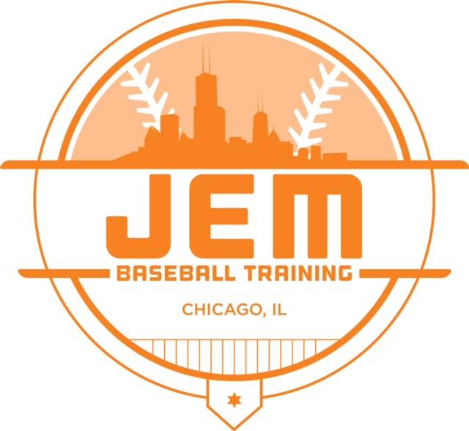 |  | #TRAINLIKEAJEM  Date Opponent Location Time  March 29-31 Bullpen Sports Tourney Indianapolis, IN TBD  April 11 West Englewood Lynwood, IL 5:30pm  April 12-14 Ho Chunk Tourney Lynwood, IL TBD  April 18 House of Sports TBD 6:00pm  April 19-21 JP Sports Tourney Arlington Heights, IL TBD  April 25 Homewood Hawks Homewood, IL 5:30pm  April 26-28 Ho Chunk Tourney Ho Chunk Lynwood, IL TBD  April 30 Morris Baseball Lynwood, IL 5:30pm  May 1 Longshots Downers Grove, IL 6:00pm  May 3-5 Bullpen Sports Tourney Indianapolis, IN TBD  May 9 House of Sports Lynwood, IL 5:30pm  May 10-12 Game Day Tourney Midlothian, IL 6:30pm  May 14 Morris Baseball Lynwood, IL 5:30pm  May 17-19 Ho Chunk Tourney Lynwood, IL TBD  May 21 Flyers Lynwood, IL 5:30pm  May 23 Cobras Chicago, IL 7:00pm  May 24-26 Ho Chunk Tourney Lynwood, IL TBD  May 28 Mid- Week Playoff Lynwood, IL TBD  May 30 Mid- Week Playoff Lynwood, IL TBD  June 4 Mid- Week Playoff Lynwood, IL TBD  June 6 Mid- Week Playoff Lynwood, IL TBD  June 8 Prospects Orland, IL 3:00pm  June 9 Prospects Orland, IL 2:00pm  June 10 Mid-Week Playoff Lynwood, IL TBD  June 11 Mid-Week Playoff Lynwood, IL TBD  June 12 Mid-Week Championship Lynwood, IL TBD  June 13-16 Bullpen Sports Tourney Indianapolis, IN 5:30pm  June 18 Celtics TBD 6:00pm  June 22 Wisconsin Hitters Caledonia, WI TBD  June 23 Wisconsin Hitters Caledonia, WI TBD  June 26 Sparks Lockport, IL 5:30pm  June 28- 30 Ho Chunk Tourney Lynwood, IL TBD  July 2 House of Sports Matteson, IL 6:00pm  July 4-7 Game Day Tourney Crown Point, IN TBD

JEM 10u
2019 Schedule

Manager: carlton hondras
Coach: Booker Hatcher
Coach: Warren Broome

WEBSITE:
Jembaseballtraining.com

EMAIL:
jembaseballtraining@gmail.com

