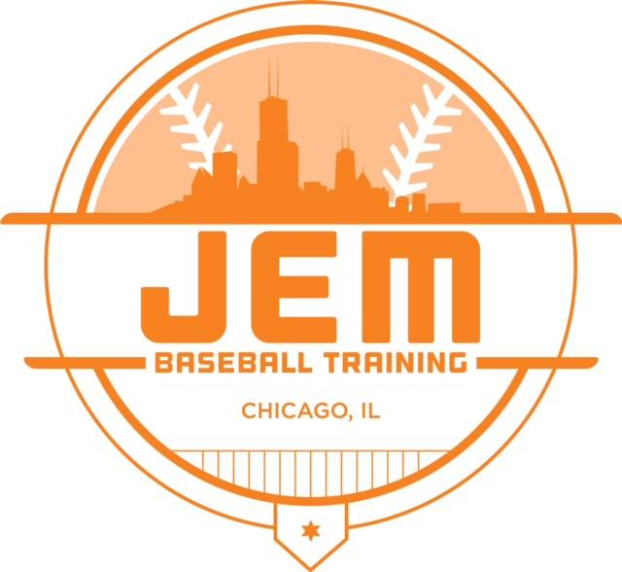 |  | #TRAINLIKEAJEM  Date Opponent Location Time  March 29-31 Bullpen Sports Tourney Indianapolis, IN TBD  April 3 Cobras Chicago, IL 5:30pm  April 12-14 Ho Chunk Tourney Lynwood, IL TBD  April 17 Muddogs TBD 5:30pm  April 19-21 JP Sports Tourney Arlington Heights, IL TBD  April 25 The Show Chicago, IL 5:30pm  April 26-28 Ho Chunk Tourney Ho Chunk Lynwood, IL TBD  May 3-5 Bullpen Sports Tourney Indianapolis, IN TBD  May 7 Longshots Baseball Downers Grove, IL 5:30pm  May 10-12 Game Day Tourney Midlothian, IL 6:30pm  May 17-19 Ho Chunk Tourney Lynwood, IL TBD  May 21 Oaklawn Lightning Oak Lawn, IL 5:30pm  May 24-26 Ho Chunk Tourney Lynwood, IL TBD  June 3 Oak lawn Lightning Oak lawn, IL 5:30pm  June 6 Mud Dogs TBD 5:30pm  June 13-16 Bullpen Sports Tourney Indianapolis, IN 5:30pm

JEM 11uor
2019 Schedule

Manager: Patrick coe
Coach: Earnest Horton
Coach: Max Huckabee

WEBSITE:
Jembaseballtraining.com

EMAIL:
jembaseballtraining@gmail.com

